**SPACE:**

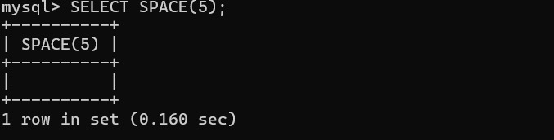

**SUBSTR:**

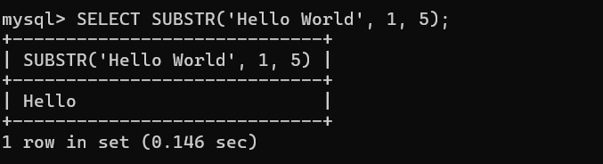

**UPPER:**

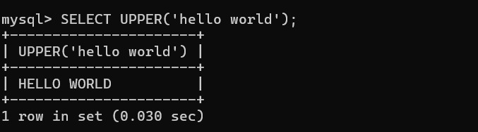

**LOWER:**

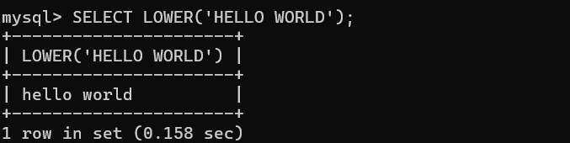

**TRIM:**

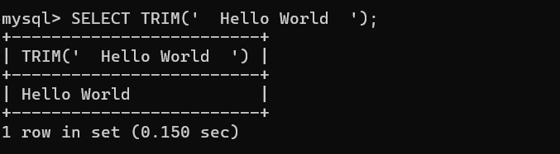

**LENGTH:**

